PARISH NEWS
The Deverills & Crockerton

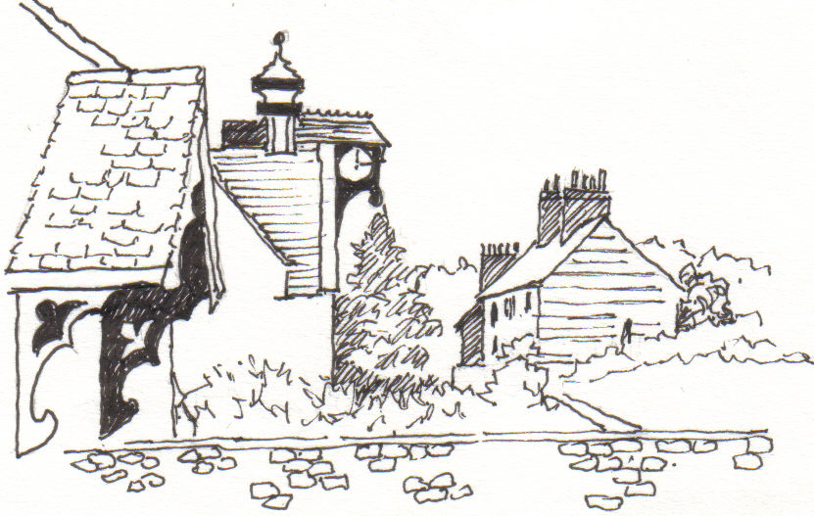

Longbridge Deverill
by Pat Armstrong

June 2009

Look inside for local information

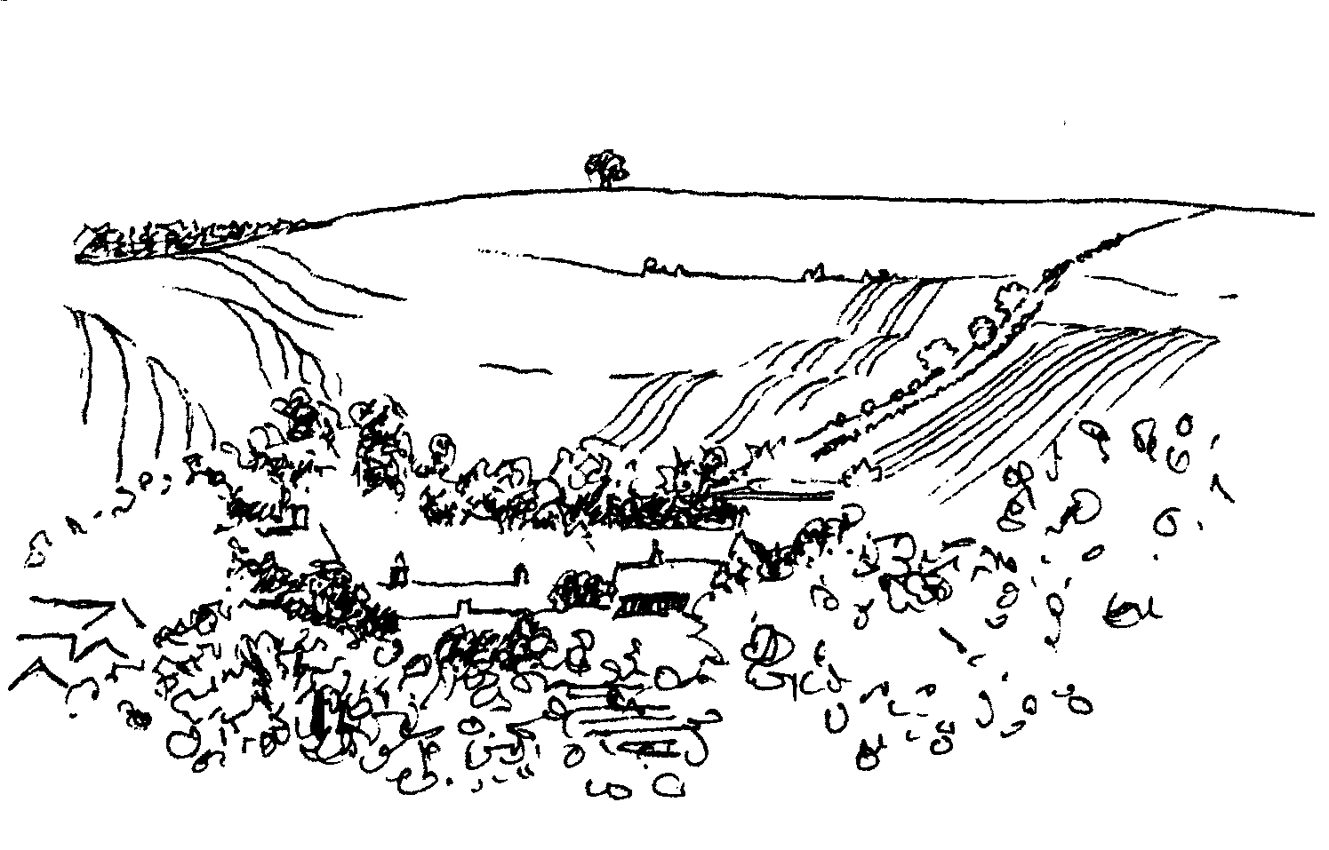
-2-
Longbridge Deverill House - Care Home for the Elderly
SUMMER FETE
Saturday 11th July 2.00 pm
Cake, Handicraft and Plant Stalls, Pets Corner
Cream teas, Raffle, Tombola,
Music & entertainment for all, please come and join us

JOB’S MILL, CROCKERTON
Open Garden Sunday 21st June
From 2.00 - 6.00 pm
In aid of the National Gardens Scheme
Please come and enjoy some time in this beautiful garden
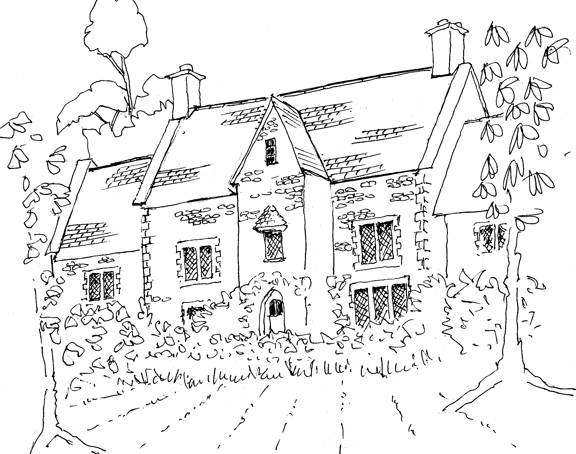

Coffee, Cards and Chat
Come and enjoy looking at the new range of cards,
ribbons, wrapping paper, and other exciting items
displayed by John and Maddie Goodden
in the Upper Deverills Village Hall on Thursday 19th February
between 10.30 and 12.00 noon - everyone is welcome
Donations will be made to the hall and the church

CROCKERTON VILLAGE COMMITTEE
Mid Summer Party at Bath Arms Crockerton Saturday 18th July from 6.00 pm
Come to a great summer event for Crockerton & local area
Music, Food, Fun, limited space so please book early £7 adults £3 children (5-10 yrs) Under 5’s free
Ring: Marion – 213739, Tracey – 216939, Bernie – 218401

SATURDAY 12TH SEPTEMBER

SUPPORT THE WILTSHIRE

HISTORIC CHURCHES TRUST

TO TAKE PART

PLEASE CONTACT

JUDY MUNRO 844385


-3-

The Rector reflects:
What a privilege it is to be able to travel in safety and relative comfort! I recently returned from a Pilgrimage to Italy, the time divided between Ravenna and Assisi. The pilgrimage was called Splendour and Simplicity, and these themes were beautifully combined as we explored wonderful art and Franciscan spirituality. The mosaics in Ravenna were a rich feast of colour and splendour. By contrast, the simplicity of the lives of Francis and his followers were testament to his vocation to ‘live the Gospel using words only if necessary’.
Our travels had many aspects, and there were many opportunities to learn about Francis, and how he came to understand God’s call. Perugia, a hill-top town, where Francis was a prisoner of war, had much to offer to those keen on art and we were able to take advantage of free entry to the art gallery (a consequence of it being a public holiday!). Back in Assisi, the Church of St. Damian where Francis first heard God’s call, was full of people but, as everyone was asked to keep silence there, it was possible to be reflective and feel something of the sacredness of the place.
The Basilica in Assisi was another wonderful place, full of splendid frescoes and paintings. The crypt of the lower basilica was also the place of Francis’ tomb and it was possible to pay homage there - another place of silence and prayer. It was an honour to hold an Act of Remembrance in the war cemetery at Rivotorto, near the site of Francis’ first friary.
A trip to Lake Trasimeno and visit to Isola Maggiore enabled us to imagine what it must have been like for Francis to get right away for times of retreat. Another place of retreat for Francis and his followers was Carceri, and the highlight of our visit there was being able to celebrate the Eucharist in the chapel.
On the journey to the airport we stopped at Tivoli to visit the famous gardens of the Villa D’Este, both house and gardens being very much on a grand scale.
It was a wonderful experience, seeing so many of the places which were significant in Francis’ life and still reflect his touch today. The best gift was perhaps the ability to shut out the crowds of people and to imagine what life must have been for Francis all those centuries ago. He certainly lived by the values he held dear and for the love of his Lord. His example is as much for today as it was in his lifetime.
Norma Payne
Longbridge Churchyard
Ian Woodcock has retired. He has ridden his mowing machine up and down the road for over 10 years, whatever the weather, to keep the churchyard in immaculate condition. He has also kept the paths clear of moss and weeds, planted daffodils and divided snowdrops making the whole area look lovely. We thank him very much for his dedication and all his hard work. The ‘new’ churchyard and Crockerton churchyard has been mown by Peter Lambourne, who also cuts the hedges. Peter will continue to do the hedges but the grass will now be cut by Terry Baxter, who specialises in churchyard mowing. It has been a bumper year for moles. Thank you to Ian Mcquiston who volunteered to be ‘catcher’, so far he has caught five; we hope you manage to defeat all the moles!

-4-

Elections - use your vote!
Wiltshire Council and European Parliamentary elections are on Thursday 4th June. Every vote counts so use this opportunity to make your voice heard. For information see www.wiltshire.gov.uk or call 0300 4560112.
Longbridge and Crockerton Community Emergency Volunteer
The Parish is looking for a new C E V following the resignation of the previous volunteer. Full training for this important post is given at County Hall in Trowbridge. If you feel that you may be interested in helping your local community in an emergency, please contact the Clerk on 840119 for more details.
Helen Few - Clerk Longbridge Deverill & Crockerton Parish Council
Save the Children Fund
Cream teas and open garden in aid of Save the Children will be held at
Mill Farm House, Hill Deverill on Sunday 28th June between 3.00 – 6.00 pm and on the last Sunday of the following months, 26th July, 30th August,
27th September. Do come and join us for an enjoyable and relaxing afternoon.
Anne Hurd
Barn Dance - Rye Hill Farm - Friday 26 June at 8.00 pm
For the third year, with kind permission of the Algars, the Rotary Club of Warminster will be holding a Barn Dance. Money raised will go to several local and international charities. The music will again be provided by the Spill the Whisky Band, a caller leading us all the way! There will be a bar and a barbecue. Tickets £10 available from Nigel Poole Tel 840902 or npoole@dsl.pipex.com. Come along for a fun evening and help support some worthy causes.

Gala Benefit Performance in aid of the RNLI

Vaughan Williams’ A SEA SYMPHONY

Hebrides Overture ~ Mendelssohn Fourth Irish Rhapsody ~ Stanford

Amanda Roocroft ~ Soprano William Dazeley ~ Baritone

The Atheneum Singers, Warminster and Bath Minerva Choir
Mid - Somerset Orchestra Conductor ~ Gavin Carr

WELLS CATHEDRAL
Saturday 11th July 7.00 pm

Tickets £25, £20 reserved; £15, £10 unreserved
available: Wells Cathedral Shop 01749 672773 or shop@wellscathedral.uk.net
Warminster Information Centre 218548 or John Budgen (Crockerton) 218203
Bath Festivals Box Office 01225 463362 or www.bathfestivals.org.uk
Travel by coach will be available from Warminster, subject to demand
-5-

Deverill Valley & Crockerton Women's Institute
The Annual General Meeting of the WI in London this year is on Wednesday
3rd June when the ‘SOS for honey bees’, put forward by Hindon WI, will be discussed. Our monthly meeting in Longbridge Village Hall will take place on Monday 8th June at 7.30 pm. The talk will be ‘The Last Romaov Tsarina’, a glimpse into an amazing and tragic lifestyle by Mollie Bond, and the social time will feature ‘Roll Call’ - a book I enjoyed and why! Come a long an join us.
Jill Russell 840209
Upper Deverills Village Hall
Annual Rounders Evening Friday 19th June
The traditional Rounders evening will take place on the cricket pitch adjacent to the village hall starting at 6.00 pm. This is an evening not to be missed, sporting skills are not necessary to take part! Bring the whole family to what is one of the most enjoyable village hall events.
Duck Race 6.00 pm Saturday 4th July
The race starts at Pope’s Farm bridge, Kingston Deverill, everyone of all ages is welcome to join in the fun. Ducks to sponsor will be on sale from 6.00 pm before the race which starts at 6.30 pm. At the end of the race there will be a delicious barbeque in the field by the river. Come along and enjoy this fun event.
Annual Summer Fete 2.00 pm Saturday 18th July
The Fete will include the usual Flower and Craft competitions and the Dog Show as well as many of the popular sideshows. Details of the classes and entry forms will be included in next month’s Parish News. In the meantime please start planning your exhibits for classes such as vegetables, plants, flowers, cookery, photos, arts & crafts, and a handwritten limerick! For the children, a plated garden, painting of your house, a handwritten ‘invitation to my party’. We welcome entries from everyone - the more we have the greater the competition and the more fun it is! It is not the winning but the taking part that counts! Please enter something.
Longbridge Deverill Village Hall
A delicious steak pie lunch was enjoyed by over 50 people in April to celebrate
t George’s Day. £250 was raised for Hall funds which enables us to maintain the Hall for the enjoyment of the Parish. Grateful thanks to all the committee and all who donated food and raffle prizes.
Forthcoming events
Saturday 25th July - Quiz Night
September - Harvest Supper
October - John’s Local Talent Music Night
December - Carol singing
If you would like to join the committee to support the village hall, please contact me, Julie Read 840655, or come to our meeting on 17th June at 7.30 pm.

-6-

Wylye Tennis Club
When you read this our 2009 match programme will be one third through and for the first time we have added a ‘Ladies’ team to complement our existing two mixed teams. All teams play within the Chippenham & District League, our Mixed ‘A’ remaining in Div. 2, the Mixed ‘B’ in Div. 5 and our Ladies in Div.4 of the Ladies leagues. As at the date of writing (6th May) we have collectively played just 5 league matches, shamefully admitting we have all lost each match. A slow and disappointing start yet there are 35 still to go so remain positive, our luck and playing standard will hopefully improve! All matches are played on a home and away basis, this year our away games spread from close by Corsley, Warminster and Trowbridge to further afield Grittleton, Urchfont, Seend and Bath. We are a small group of players/friends, almost all from within this Parish News area and always pleased to welcome new players. If you play tennis or you have a tennis court in your garden and would like to meet and play with other like minded parishioners, please give me a call. We use new cans of balls for each home match, they are played with for only one evening and are then available for sale. £2.00 per can of four (Wilson US Open).
Colin Singer 213696
Broadband Action Group (BAG) Update May 2009
Since the Broadband Action Group reported progress in the April Newsletter, members of the group have held a meeting with two representatives of BT. One represented Openreach (responsible for cabling i.e. the hard wired infrastructure linking homes to exchanges) and the other BT Networks (the business side and providers of services). They reported that cabling had been checked and found to be reasonable within the tolerances laid down. Furthermore they expressed the view that the level of complaints they have received from users in the Upper Deverills is well within the average for rural users nationally. They have also considered and priced the provision of new cabling to Monkton and Kingston and estimate it at half a million pounds. Financially this was deemed to be a non-viable option. Finally, BT agreed to pursue further the cases of two local users who are experiencing serious reliability problems. A BT engineer will report back on this.
Some readers will be aware of a report on 21st April in the national press of a statement made at that time by Lord Carter, the Communications Minister. He is alleged to have stated “Large parts of Britain may not get access to superfast broadband internet because building the network to deliver the service is too expensive”. You will be only too aware that in our valley, we do not even benefit from any reasonable speed of broadband! His report is due to be published in June. We await it with bated breath!
Thus we are left to learn the findings of the reliability investigations concerning our two local residents and must be prepared to respond to Lord Carter after his report is published. BAG are investigating alternatives, one possibility, but only that, involving the use of satellite technology to address some of the shortcomings.
Robin Greenwood

-7-
The Deverills Cricket Club
The new season started on 26th April with an away match at Steeple Langford. Home matches take place on the cricket ground next to the Upper Deverills village hall, please do come along to watch and support us. Home fixtures are on:
14th & 28th June, 5th & 26th July,
16th, 23rd & 31st August, 6th & 13th September
If you would like to join the club and require further information please call Pete Child on 01963 34593 or Jamie Fagan on 844123 / 07796 698180.
Traffic Issues Update
Proposed Closure of the A303 for Essential Repairs
InteRoute, the company commissioned by Wiltshire Council to carry out the repairs on the A303, has submitted 6 closure options to the Department of Transport who are expected to select their preferred option within the next two weeks. The main difference between the new schemes and the original discredited plan is that instead of closing the whole road between Mere and Willoughby Hedge for repair, the work will instead be completed in small sections. This will make it possible to keep the road open for longer by using single lane closures, particularly at night. That said there will still be a need to close the A303 but for a shorter period than envisaged in the original plan. The option selected by the Department of Transport will be aired at a second series of information events to be held in July, hosted by InteRoute. Once details of these events are known the information will be included in the Parish News.
Proposed Weight Restrictions
To date Wiltshire Council has received approximately 170 representations with reference to the proposed weight restrictions on a number of routes, including the B3095. No decision will be made until the new Council is formed in June and therefore it is unlikely that any pronouncement will be made before July/August at the earliest.
Litter Collection on the B3095
It is proposed that an ad hoc litter collection team is formed to collect rubbish on the verges of the B3095. We have contacted Wiltshire Council to determine what needs to be done in order to comply with safety and indemnity issues. Assuming we get the go-ahead we will be looking for volunteers.
Speed Monitors
You may well have seen the speed monitors on the B3095 last year. Their purpose is to make drivers more aware of their speed and therefore stick to the speed limit. The monitors are normally left in place for a period of a fortnight and then moved to a new site. The reason for this is trials have identified that if they are left in place for longer they start to lose their deterrent effect. We have requested the use of the monitors again and hope to get them in July for a two week period.
Ranald Blue 841374

-8-

SERVICES PARISH OF DEVERILLS & HORNINGSHAM
Sunday Trinity
7th June Kingston 8.00 am Holy Communion 1662
Longbridge 10.30 am Morning Worship
Horningsham 6.30 pm Evensong
Sunday Trinity 1
14th June Kingston 10.30 am Holy Communion
Horningsham 11.15 am Holy Communion
Sunday Trinity 2
21st June Longbridge 8.00 am Holy Communion 1662
Brixton 10.30 am Holy Communion
Sunday Trinity 3
28th June Longbridge 10.30 am Holy Communion
Horningsham 11.15 am Morning Prayer
Brixton 6.00 pm Evening Prayer
Sunday Trinity 4
5th July Brixton 8.00 am Holy Communion 1662
Longbridge 10.30 am Morning Worship
Horningsham 6.30 pm Evensong

Tuesday Wednesday Thursday Friday Longbridge 8.30 am Prayers
Wednesday Longbridge 10.15 am Holy Communion

The Deverills & Horningsham Register
Baptism at Horningsham Honor Frances Coombes on Sunday 10th May

Wedding at Kingston Andrew Clune & Sarah White Saturday 23rd May

Wedding at Brixton Christopher Rose & Christine Fitton Saturday 30th May

Ivy House St Denys Retreat Centre
Friday 12th June - Quiet Garden Day
with Midday Eucharist
A place for rest, refreshment and renewal
To book and for more information please phone 214824
Contact the Clergy
Please contact Norma Payne (841321) or Di Britten (01373 832515) if anyone is housebound and would like communion or a visit at home; or if someone is ill and needs our prayers; or to discuss any church matter.
Office administrator phone 210149 or email: office@cleyhill-team.org.uk

-9-
SERVICES PARISH OF CORSLEY & CHAPMANSLADE
Sunday Trinity
7th June Corsley 9.00 am Holy Communion
Sunday Trinity 1
14th June Chapmanslade 9.00 am Holy Communion
Temple 11.00 am Morning Prayer
Sunday Trinity 2
21st June Chapmanslade 9.00 am Holy Communion
Temple 12.30 pm Baptism
Corsley 6.00 pm Evening Worship
Sunday Trinity 3
28th June Temple 9.00 am Holy Communion 1662
Corsley 10.30 am Parish Service
Sunday Trinity 4
5th July Corsley 10.30 am Parish Service

The New Deverill Choir
Many thanks to all for the enthusiastic start to the new choir on 8th May. It was a great opportunity to meet new faces and to enjoy singing together. We will be singing a variety of music, from rounds and folk songs to sacred songs and learning to sing in parts. There is potential for informal performances over the coming months. No experience is necessary, just enthusiasm! Do come and join us on Fridays at 7.30 pm in the Bath Chapel of Longbridge Deverill Church, I look forward to seeing you.
Claire Johnson 840787
Church Cleaners for June
Kingston - Mrs Stratton & Mrs Mounde
Brixton - Mrs Allard & Mrs Sutton
Longbridge - Monday 1st June 9.30 - 10.30 am - all helpers please
Church Flower Arrangers for June
Kingston Brixton Longbridge
7th June Mrs Williams Lady Walker Mrs Woods
14th June Mrs Williams Mrs Mcdonald Mrs Woods
21st June Mrs Munro Mrs Mcdonald Mrs Birts
28th June Mrs Munro Mrs Lawson Mrs Birts

Concert Dates for your diaries
Saturday 1st August - Jazz and supper at Brixton Deverill ring 840877 for tickets.
Saturday 17th October - Deverill Valley Clarinet Quintet and supper at Longbridge

Church Cleaners for June
Kingston - Mrs Stratton & Mrs Mounde
Brixton – Mrs Allard & Mrs Sutton
Longbridge - Monday 1st June 9.30 - 10.30 am - all helpers
Church Flower Arrangers for February
KingstonBrixtonLongbridge7th JuneMrs WilliamsLady WalkerMrs Woods14 JuneMrs WilliamsMrs McDonaldMrs Woods21st JuneMrs MunroMrs McDonaldMrs Birts28 JuneMrs MunroMrs LawsonMrs Birts

-10-

Annual Parochial Church Meeting
The APCM took place on 19th April preceded by a Service of Evening Prayer at Longbridge Deverill. Thirty eight parishioners turned out to vote in the Churchwardens and PCC members. Tim Moore, Mike Tulloch, Mary Stewart Cox and Elisabeth Atkinson were re-elected unanimously. Nigel Poole expressed his wish to retire as churchwarden having served for a number of years. Mari Poole, Julian Wiltshire, Margaret Askew, Jane Yates, John Oborne and Fran Chris stood down from the PCC and were replaced by Richard Wilson, Henry Johnson, Claire Johnson and Judy Munro. Nigel Poole agreed to take over the post of Secretary. The Treasurer, David Stratton, presented the accounts which were accepted. The Sidesmen and Sideswomen were all re-instated. The Rector, the Reverend Norma Payne, reported enthusiastically and positively on her work over the past year. She was warmly thanked by Canon Richard Askew. A report from the Thursday Group, leader Barbara Beilby, was presented by Sylvia Titt. The meeting ended on a social note with wine and delicious savouries, for which many thanks go to Mari and Nigel Poole and the ladies of the Parish.
Anne Honley
Victoria County History of Wiltshire

In response to the item about Wiltshire History in the May newsletter, I attended the meeting at the Warminster Library. Dr Virginia Bainbridge, the editor, explained the background of the Victoria County History series and gave a brief outline of the work accomplished in other areas. They have now come to Volume 19 in the Wiltshire series, which will include all the parishes in our local area. Dr Bainbridge asks that we all search out items that reflect life in our area. Remember to ask any friends or relatives that have moved away. Also required are volunteers to search out newspaper articles and wills and identify buildings. More information can be obtained from Helen Taylor on 01249 705500 (daytime) or from the Historian at Warminster Library who will also be able to receive items of interest. Should you wish to see previous works in other areas, these are available free online at www.british-history ac.uk.
Les Wood

Contact the Editor and the Website
Parish News Editor: Judy Munro 844385
Contributions for the Parish News through my letterbox or
by post to Whitepits Lodge, Kingston Deverill, Warminster,
BA12 7HD or by Email: judymunro@tiscali.co.uk Thank you
Please remember the deadline is the 15th of every month
Website: www.deverills.org.uk
Email address: info@deverills.org.uk
Website manager: Kate Wilkinson 844998
Contents: Parish News with church services, Parish Register, Events,
Local news plus pictures and other information.

CONTACT THE EDITOR AND WEBSITE
Parish News Editor - Judy Munro 844385
Contributions for the Parish News through my letterbox or
by post to Whitepits Lodge, Kingston Deverill, Warminster,
BA12 7HD or by Email: judymunro@tiscali.co.uk Thank you
Please remember the deadline is the 15th of every month

Website: www.deverills.org.uk Email address:info@deverills.org.uk
Website manager : Kate Wilkinson 844998
Contents: Parish News with church services, Parish Register, Events, Local News plus pictures and other information
-11-
Fifth Wylye Valley Art Trail Saturday 30th May - Sunday 7th June
This biennial festival of open studios, workshops and exhibitions, is within a 12 mile radius of the centre of the Wylye Valley, south Wiltshire, covering Hindon, Tisbury, Mere, Warminster, Westbury and villages in between. Since the first event in 2001, the Art Trail has developed into the largest visual arts event in Wiltshire, attracting many local artists, craftspeople and groups and bringing in large numbers of visitors. The artists taking part range from regionally and nationally acclaimed figures, those beginning to make names for themselves locally and some discovering their talents as students or members of groups. Each have a unique vision, a particular way of making art, contributing to the exciting cultural profile of this part of the county. Events taking place in The Deverills and Crockerton are as follows:
Event 32: Exhibition of paintings by Pat Armstrong and the 'Look and See' group at Kingston Deverill Village Hall open 10.30 am to 5.00 pm, except Thursday 4th June
Event 33: Batik (wax resist and dye on fabric) paintings of wildlife and nature by Mandy Martyn at The Garage Gallery, 67 Kingston Deverill.
Event 34: Contemporary paintings, prints, photography, jewellery, furniture, sculpture at The Barn, Manor Farm, Monkton Deverill. Artists: Sandy Crole, Margaret Turner, Johnny Bull, Gerry Baptist, Rupert Bevan, Tim Harrisson, Thom Bridle.
Event 35: Exhibition of contemporary woodwork and photography by Antaro Ofer Margolin – all inspired by this beautiful valley. Also a collection of vibrant mixed media paintings by Angie Margolin at 2 Whitecliff Farm Cottages, Brixton Deverill.
Event 36: Studio 90 at Mill Farmhouse, Hill Deverill: paintings covering a wide range of subjects by Mike Allardice, Julia Haes, Amanda Harris, Sandrine Maubeche, Jo Miln, Mark Muspratt-Williams, Jane Parsons.
Event 37: Panoramic photography and video art by Jean-Paul Sant. Screenprints, collographs and monoprints by Maggie Sant. Also abstract paintings by Tony Sant at ‘Riverside’, Sand Street, Longbridge Deverill.
Event 38: Exhibition at Lakeside Garden Centre, Crockerton: paintings from still-lives and interiors to skyscapes and other curiosities by Jules Horn. Also cyanotypes of flowers and papographs by Jennie Gilling in which handmade paper is merged with photographic details.
Event 39: Artists and craftspeople living and working at Bull Mill are opening their studios and workshops to show a wide range of contemporary art, including painting, sculpture, jewellery, printmaking, photography, gilding and textiles. Nick Andrew, Kate Andrew, Sally Alexander, Olivia Clifton-Bligh, Daniel Petkoff, Dean Brodrick, Stephanie Gilbert, Joanna Sims and Philip Leevers.
Event 40: Woodturning by Trevor Parry, turned and sculpted from a wide selection of native and exotic woods at the Wylye Valley Vineyard, Sutton End, Crockerton.
Event 41: Exhibition at Wylye Hall studios (formerly Holy Trinity Church), Potters Hill, Crockerton, of digital printmaking and mixed media by Jane Humphrey, mixed media paintings and prints by Sue Conrad and delicate and detailed pencil drawings by Kim Underwood.
Images and more details in the guidemap, available at Longbridge Deverill Garage, The Bath Arms and Lakeside Garden Centre or go to www.wvat.co.uk

-12-

Neighbourhood Watch

The spring weather is encouraging us all to spend more time outside in the garden and to open the windows and let the breeze blow away the traces of winter. But remember when going out; securely lock all doors and windows, no matter what the temperature and how long you intend to be away. Just popping across the road for a minute or just nipping down to the shop is ample time for a criminal to strike. If you are in the back garden lock the front door. Generally thieves like the easy option so simple efforts like making sure doors and windows are secure when you go out or when you go to bed will put them off. Simple advice but often forgotten. If you see anyone acting suspiciously in or around premises or unusual vehicles in your neighbourhood try to take a description and the registration number. Don’t approach any suspicious people – please tell us about them. For information on how to improve your home security contact the local Crime Reduction Officers or your Neighbourhood Policing Team on 0845 408 7000.
P C Vicki Pegrum
Where have you been?
The Potting Shed Café at Pythouse Kitchen Garden, West Hatch, Tisbury 01747 870444 and www.pythouse-farm.co.uk
If you like good food and you also like plants then this is for you. Pythouse Kitchen garden is a very special place although not easy to find, unless you know the back lanes around Tisbury and Semley, but it is well worth the effort. It is about 2.5 miles west of Tisbury on the Newtown to Semley road. The Potting Shed is actually a long, low, brick-built building, delightfully furnished and displaying paintings by local artists, which are for sale. The building opens onto a covered terrace which overlooks the Victorian walled kitchen garden. We had lunch there mid-week in late April. The food was delicious! The owners pride themselves on using what is in the garden so their menu changes with the seasons. They were very obliging when I asked if the soup contained any dairy products, it did but they made me a portion without and pretty quickly too! Everything seems to be home made and locally produced. Stews, quiches, organic burgers, tarts, pies and soups are served plus an all day breakfast. They don’t serve wine but you can bring your own to enjoy with your lunch. There is also a small but well-stocked delicatessen which sells their own organic meat and a selection of fresh locally sourced produce, including in-season fruit and vegetables from the kitchen garden. I recommend Mrs Mack’s Organic Poppy Seed Dressing, which is used on the café salads and can be bought in the shop. If you buy a lot in the delicatessen they sell very good heavy duty cotton bags for all your shopping which are about £2.00 and have the Pythouse logo on them. I think they are good value because they are very strong and the handle will go over your shoulder. There is also a facility to pick your own fruit and vegetables. Opening times are from 8.30 am to 5.00 pm every day except Tuesday. Pythouse Walled Garden is signposted from the A350 near Semley.
If you have somewhere you would like to recommend, please send your comments and suggestions to me by email at farthings.kd@btinternet.com or through my letter box at Farthings, Kingston Deverill.
Trish Shuler

-13-

Crockerton School – New Mobile Project
Just a quick update on the mobile project. We have gone through contract tendering and have selected PJ Dyke. They are a small company with a wealth of building experience and a track record of successful delivery. The project started on 21st May with the marquee being erected in the playground, followed by the removal of the old mobile.
The project is expected to take 10 weeks. We have asked that traffic movements to and from the site avoid the times of 8.00 - 9.00 am or 2.30 - 3.30 pm. We are expecting the new mobile to be brought to site during the week of 22nd June and will take two days to complete. There should be no road closure connected with this; the road will have cones placed along it the day before. There will be regular progress updates on the school website at http://www.crockerton.wilts.sch.uk. We have also asked Dyke’s to ensure that a copy of the plan of works is fixed to a prominent position on the safety fencing surrounding the site.
I will also be setting up a distribution list for e-mail communication, as plans sometimes need to change at short notice! If you would like to be added to this list please e-mail me at Graham@fontof.co.uk
Graham Dopheide - Chair of Governors
Recipe of the Month - Panna Cotta with Seasonal Fruit
Serves 4; preparation time 20 minutes; cooking time 15 minutes.
Ingredients (all are available to purchase in the shop)
4 tbsp caster sugar
2 leaves gelatine or 2 tsp powdered gelatine
300 ml double cream, 150 ml milk (optional: 170 gm mascarpone or clotted cream)
Method
- Simmer caster sugar, double cream and milk for 5-8 minutes. Stir occasionally.
- Either soak the gelatine leaves in water until soft, squeeze out and add to cream, stir until dissolved; or stir gelatine into 30 ml of cold water, allow to soften, put over boiling water, stir until the gelatine has dissolved. Then mix into the cream.
- For a richer cream stir in the mascarpone or clotted cream.
- Lightly oil four containers (200 ml ramekin dishes, glass or plastic pots) and pour in the mixture. Cool, cover and chill for at least 3 hours or overnight.
- To turn out dip each container into hot water for 30 seconds and turn onto serving dish, shake to release or slide a knife around the edge to release.
- Serve with seasonal fruit:
- rhubarb sprinkled with sugar, roasted for 10 minutes;
- strawberries, vanilla extract, sugar and water heated together then crushed;
- cranberries, sugar and orange juice heated together, blended and sieved;
- fruits of the forest with a sprig of mint; Raspberries tossed in Grand Marnier.
This recipe is sponsored by Maiden Bradley Community Shop (844206)
The Post office is open: mornings only.
Shop opens: Monday, Tuesday, Thursday, Friday 8.00 am – 6.30 pm;
Wednesday 8.00 am – 6.00 pm
Saturday 8.00 am – 1.00 pm; Sunday 10.00 am – 12.00 noon

-14-

LOCAL COUNCILS, SOCIETIES, GROUPS etc.
Longbridge Deverill and Crockerton Parish Council
Karen Manfield 215526 (Chair) Peter Whithey 840347 (Vice Chair)
Helen Few 840119 (Clerk) Thomas Minter 216909
Bill Hurd 840023 Elaine Pidgeon 212878
Julian Algar 840816 Graham Read 840296
Brian Marshall 214789
Upper Deverills Parish Council
Lady Felicity Wheeler 844683 (Chair) Ranald Blue 841374
Jacqueline Smith 840238 (Clerk) Patricia Shuler 844291
Sarah Fagan 844123 Robin Greenwood 840743
County Councillor
Fleur de Rhé Philipe 213193

Longbridge Deverill Village Hall Committee
Julie Read 840655 (Chair) Sylvia Titt 214825 (Caretaker)

Upper Deverills Village Hall
Richard Cousens 844970 (Chair)
Mandy Martyn 844320 (Secretary) John Lea 844325 (Hall bookings)

Crockerton Millennium Committee
Marion Thomas 213739 (Chair)

Pre-School Children and Parents ‘Thursday Group’
Barbara Beilby 844995 (Chair) Sylvia Titt 214825 (Leader)

Deverill Valley & Crockerton W I
Ruth Sutton (President) Jill Russell 840209 (Secretary)

Sir James Thynne Almshouse
Mrs Sue Jackson 840322 (Steward)

Deverills Cricket Club
Jamie Fagan 844123 Peter Child 01963 34593

Wylye Valley Tennis Club
Colin Singer 213696

Wylye Valley Flower Club
Mrs Hazel Yate 215617 (President) Mrs S Scott 213689 (Programme Secretary)

Wiltshire Wildlife Trust
Elm Tree Court, Long Street, Devizes SN10 1NJ www.wiltshirewildlife.org

Rural Community Beat Officer - Police Community Support Officers
PC Vicky Pegrum - PCSOs Ian Owen & Caroline Wright - 0845 408 7000

Hospital Transport Link Scheme 211655

-15-

F O R T H C O M I N G E V E N T S
Forthcoming Events

- F O R T H C O M I N G E V E N T S
- Scottish Dancing Monday Evenings Aline Fry (841054)
- Badminton Mondays & Fridays 3.00 - 5.00 pm Alison Rymell (844819)
- Bell Ringing at Longbridge Wednesdays 7.30 pm Richard Munro (844385)
- Hearing Loss Lip-reading Wednesdays Margaret Head (213259)
- Pre-school & Parents Group Thursdays 10.00 - 11.30 am See p14
- New Deverill Choir Fridays 7.30 pm Claire Johnson 840787 See p9
- Wylye Valley Art Trail Saturday 30th May – Sunday 7th June See p11
- Council and European Elections Thursday 4th June See p4
- Women’s Institute Evening Meeting Monday 8th June See p5
- Wylye Valley Flower Club Outing to Wisley Tuesday 9th June See p14
- Ivy House Quiet Garden Day Friday 12th June See p8
- Deverills Cricket Club Sunday 14th June See p7
- Upper Deverills Village Hall Rounders Evening Friday 19th June See p5
- Job’s Mill Open Garden Sunday 21st June See p2
- Barn Dance Friday 26th June See p4
- Deverills Cricket Club Sunday 28th June See p7
- Save the Children Teas and Open Garden Sunday 28th June See p4
- Upper Deverills Village Hall Duck Race Saturday 4th July See p5
- Deverills Cricket Club Sunday 5th July See p7
- Longbridge & Crockerton Parish Council meeting 7.30 pm Monday 6th July at Longbridge Village Hall See 14
- Upper Deverills Parish Council Annual Meeting 7.30 pm Wednesday 8th July Upper Deverills Village Hall See p14
- Longbridge House Summer Fete Saturday 11h July See p 2
- Sea Symphony Wells Cathedral Saturday 11th July See p4
- Upper Deverills Village Hall Summer Fete Saturday 18th July See p5
- Mid Summer Party Saturday 18th July See p2
- Quiz Night Saturday 25th July See p5
- Deverills Cricket Club Sunday 26th July See p7
- Save the Children Teas and Open Garden Sunday 26th July See p4
- Jazz Concert Saturday 1st August See p9
- Deverills Cricket Club Sundays 16th, 23rd, 31st August See p7
- Save the Children Teas and Open Garden Sunday 30th August See p4
16-
PARISH OF DEVERILLS AND HORNINGSHAM
Churches
SS Peter & Paul the Apostles Longbridge Deverill
St Michael the Archangel Brixton Deverill
St Mary the Virgin Kingston Deverill
St John the Baptist Horningsham
Rector
Rev Norma Payne, 6 Homefields, Longbridge Deverill 841321
Clergy
Rev Diana Britten, 69 Lane End, Corsley 01373 832515
Licensed Lay Ministers
Mr John Budgen 218203
Col Robin Chappell 212153
Churchwardens
Mrs Elisabeth Atkinson (Longbridge Deverill) 212129
Mrs Mary Stewart Cox (Brixton Deverill) 840877
Major Mike Tulloch (Kingston Deverill) 844381
Mr Tim Moore (Horningsham) 844336
Lay Pastoral Assistant Co-ordinator
Rev Norma Payne 84l321
PCC Treasurer
Mr David Stratton 844549
PCC Secretary
Mr Nigel Poole 840902
Church Electoral Roll Officer
Major Mike Tulloch 844381
Parish News Editor
Mrs Judy Munro 844385
Organist
Mr John Budgen 218203
Tower Captain
Mr Steven Young 212796
Caretaker - Longbridge Church
Mrs Sylvia Titt 214825
Office Administrator (Mon -Thurs 10.00 - 12.00)
Mr Dick Collins, 22 Church Street, Warminster 210149

